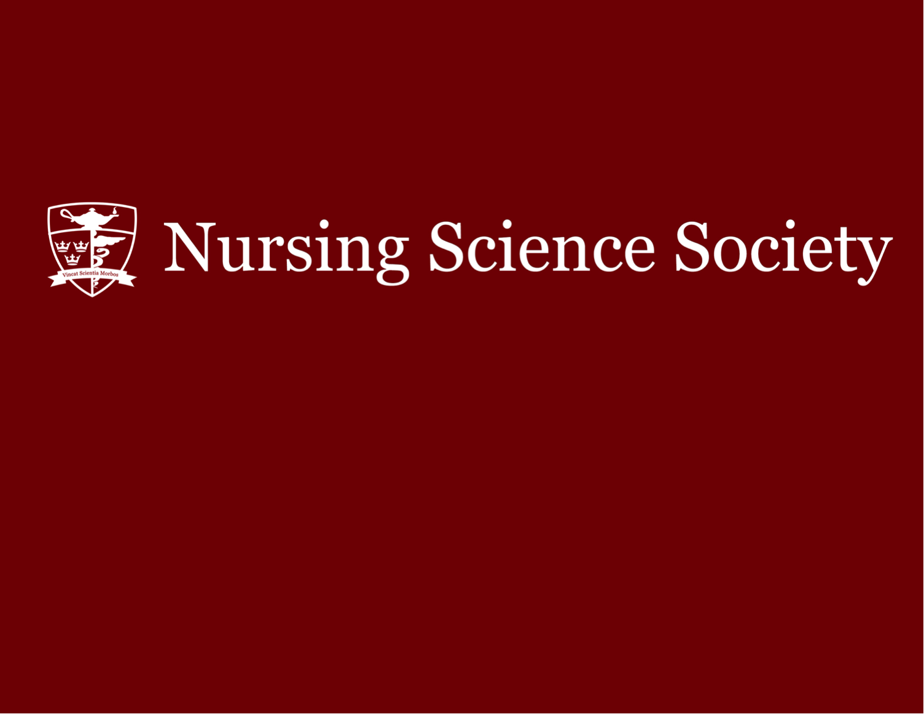

Study Buddies Tutoring Program
Winter 2026 Final Exams Application

Name:
Current Year:
Queen’s Email:
Student Number:
Course(s) Applying for:
Letter grade received in the course(s) applying for:

Please answer the following questions truthfully and to the best of your ability:

- What experience do you have helping your fellow students? (max. 150 words)

- Describe one of your favourite classes you have taken at Queen’s - what made it so great? (max. 50 words)

- How do you plan on making your tutoring sessions successful and engaging? (max. 150 w0rds)

Please email your application to Reaghan Harris at academics@nss.queensu.ca by March 14th 2026, at 11:59PM.

