

2025 NSS Fee Breakdown

Presented by: Victoria Mihaylova, Vice President of Operations
Fiscal Year: January 2024 – December 2024
Completed on: November 27, 2024

Introduction

The 2025 NSS Fee Breakdown is a detailed explanation of funding allocation by the paying student. Breakdown and presentation of these values ensures financial transparency of all NSS expenses.

Preliminary Information

Number of students…………………………………………………………………………………………….656

Current NSS ancillary fee per student...………….……………………………………………..$95.84

Summary of Funds

Predicted revenue (‘income’)………………………………………………………………..…$69,871.04

Predicted budget (‘use’).………………………………………………………………………..$52,237.64

Net residual (‘remaining’).…………………………………………………...……………..$17,633.40

Predicted Revenue

Revenue is calculated based on nursing student fees through NSS fees, the Financial Stability fee, and the 2024 surplus. The Alma Mater Society (AMS) of Queen’s University directs the money to the NSS by depositing 90% of fees in Dec. 2024 the Winter 2024 term and 10% of fees in the summer of 2025 for the Fall 2025 term. Thus, 100% of student fees to the NSS are received by Fall 2025.

90% of Student Fees………………………………………………………..…………………….$55,267.34

10% of Student Fees………………………………………………………..………………………$6,140.82

Financial Stability Fee……………………………………………………….…….………………$1,462.88

2024 Surplus……………………………………………………………………………..…………….$7,000.00

Total Revenue……………………………………………………………………….……………….$69,871.04

Predicted Budget – Financial Breakdown

Please see ‘2025 NSS Student Fee Chart’ for a visual depiction of NSS student fee allocations.

Health Training and Workshops - $1312.00
Health and Wellness Commissioner

Health and Wellness training workshops and wellness related events. Events and resources may include exam destressors, mental health training, OSCE workshops, and speaker series.

Professional Development - $1312.00
Academics and Professional Development Commissioner

Academics and Professional Development Commissioner's portfolio is to provide workshops, skill building, networking opportunities for students to expand their professional skill set and discover career opportunities.

Study Buddies Program - $1751.52
Academics and Professional Development Commissioner

Study Buddies is a program where upper year tutors are hired to hold open tutoring sessions in specific courses for nursing students. This program runs both terms and sessions are geared around the timing of midterm and final exams.

NSS Assembly Meetings - $1279.20
Executive Team

Open attendance and informative approaches to bi-weekly assemblies is promoted through space rentals, food, and appreciation to guest speakers. All students are welcome to attend and learn about positions and opportunities.

Class Councils - $4,244.32 / 6 classes = $707.39 per council
Class Councils

Class councils run events to increase and strengthen rapport within the year and between different years. The fee allows for events, fundraisers, treats and more to be done to support the class and contribute to graduation fees.

Graduation Fee - $16,911.68
Class of 2025 (four-year and AST) Class Councils

For the pinning ceremony, a longstanding tradition for nursing students, which runs in conjunction with convocation. Pinning committee uses the funding for the venue, decorations, graduation gifts and tickets, alongside fundraising.

Health and Wellness Portfolio - $1607.20
Health and Wellness Commissioner

To provide resources to help inform students about health and wellness in relation to nursing and provide opportunities to practice those skills. Events, such as Zumba and yoga, are run throughout the year alongside other initiatives.

Intern Project - $734.72
Interns

Allows for the NSS interns to develop or integrate a project, initiative or resource into the nursing community and highlight nursing students. Previous projects included a media project and redesigning the nursing student lounge.

NSS Appreciation - $1607.20
Executive Team

Allows for a token of appreciation to be awarded to NSS assembly members and thank them for their contributions to the society during their term.

NSS Office - $1312.00
Executive Team & Interns

Maintenance and upkeep of the NSS Lounge and office, including coffee and tea for students, replacement of damaged items, snacks, utensils and school supplies for the use of students.

NSS Website - $1666.24
Vice President, Operations

The NSS website is an interface with details about the NSS assembly, assembly minutes and agendas, calendar, and photo gallery. Students can find important nursing-related information, tips and tricks, and ways to get involved.

General Bursary - $1823.68
Executive Team & Head Capes

NSS financial aid available for nursing students who apply in order to participate in nursing related events or Orientation week. The NSS General Bursary is available to all undergraduate nursing students.

Orientation Week - $14,432.00
Head Capes

Orientation Week is a week for students to familiarize themselves with nursing and Queen’s University. During the week, the NSS hosts a meet-and-greet and lunch on 'Beach Day' to orient incoming students to services and opportunities.

Student Initiative Fund - $2118.88
Executive Team

The NSS Student Initiative Fund is funding for nursing students who may need financial aid or who submit a proposal for an initiative that benefits nursing students. This fund supports student projects, ideas, events, or collaborations.

NSS Events- $4093.44
Events Commissioner

This fee helps to fund NSS-planned social and professional development events and other NSS activities. Also supports the planning of events like career fair and nursing formal.

NSS Executive Honorarium- $4,165.60
President, VPOPs, VPUA, Senator

The Executive Honorarium is an appreciation for the volunteer services and dedication of the Executive and will be divided equally between the President, VPOPs, VPUA and Senator.

NSS 4-Year Track Head Cape and NOC Honorarium- $1,036.48
Head Cape and NOC
This fee is in appreciation of the volunteer services of the organizers of Nursing Orientation with 26% going to Head Cape and 74% equally divided amongst the remaining Committee members

Banking Charges - $10.00
Vice President, Operations

The NSS manages its operating budget through electronic banking software and requires small annual operating fees to maintain an account in good standing.

AMS Annual Voting Fee - $125.00
Vice President, University Affairs

The NSS uses the AMS online voting system for all elections and pays an annual service fee to continue using this interface.

2025 NSS Student Fee Breakdown – Chart
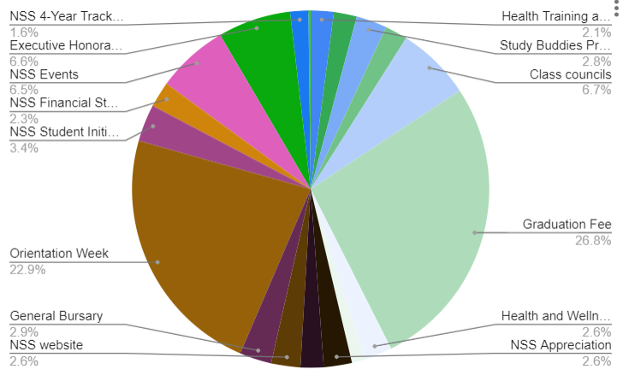

2023 NSS Fee Breakdown ( Actual)

Total spent in 2024: $42,061.24
Total earned (events, bank fees, student fees (financial stability), etc): $18,914.45
Final spending for 2024: $23,146.79
Predicted spending: $52, 237.64

Approximate Costs
Study buddies- $700.00
Predicted- $633.92
Difference- $66.08

Class councils- $3,269.00
Predicted- $2,643.22
Difference- -$625.78

O-week- $7,155.40
Predicted- $1,358.40
Difference- -$ 5,797.00

NSS Assembly meetings- $170.49
Predicted- $396.20
Difference- $225.71

Professional development (career fair and palliative panel)- $1,565.09
Predicted- $280.70
Difference- -$1,284.39

Graduation- $14,015.48
Predicted- $14,025.48
Difference- $10.00

Website- $326.45
Predicted- $316.96
Difference- -$9.49

Formal- $12,068.25 + $10,395.00 (money we made)
Predicted- $ 0
Difference- -$ 1,673.25

NSS Appreciation- $300
Predicted- $566.00
Difference- $266.00

Health and Wellness Portfolio (exam care packages, Zumba)- $319.51 - $111.00 (money we made)= -$208.51
Predicted- $820.70
Difference- $612.19

NSS Office- $20.00
Predicted- $192.44
Difference- $172.44

General Bursary- $518.40
Predicted- $905.60
Difference- $387.20

Interprofessional games- $141.04
Predicted- $566.00
Difference- $424.96

Unused Fees
NSS Athletics
Mentorship Program
Student Initiative Fund
Textbook Library
National Nursing Students’ Week
Intern Project
CNSA Membership
NSS Athletics
Words of Wisdom
Health and Wellness Training Workshops
*The funds form the above fees have been re-allocated to more accurately reflect the needs of the NSS in 2025.
Remaining
Remaining- $7000.00

There is a significant increase in surplus due to a high surplus arising from COVID-19 restrictions in the 2020 and 2021 budgets and discrepancies in 2020 budget calculations from 2019.
Does not reflect an exact 90% of student fees as $4400 was withheld from the NSS Graduation Fee in the Dec. 2021 deposit from an interim ORT invoice.
May not reflect an exact 10% of student fees as $4400 was withheld from the NSS Graduation Fee in the Dec. 2021 deposit from an interim ORT invoice.

